**📊 Social Media Sentiment Analysis Report: April Theory**

**🔍 1. Introduction**

This report presents a sentiment analysis of social media posts related to the **April Theory**. The goal is to understand public sentiment, identify emotional trends, and uncover the most frequently discussed topics throughout the month of April. Social media data was collected and analyzed using natural language processing (NLP) techniques in Python.

**🛠️ 2. Methodology**

**2.1 Data Collection**

**“The dataset used in this analysis was created manually by entering sample data directly through code in Google Colab to simulate social media posts related to the April Theory.”** The dataset used in this analysis, titled april_theory_final_dataset.csv, consists of social media posts related to the April Theory. It includes:

* A **text column** containing the body of each post
* A **created_at column** indicating when each post was made
* A **top_words column** representing key words per post

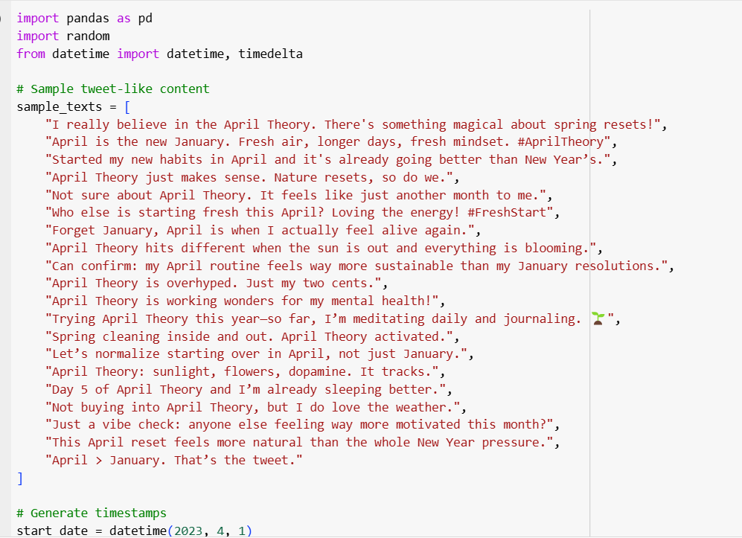

**2.2 Text Preprocessing**

The text was cleaned using the following NLP steps:

* Removal of URLs, special characters, and numbers
* Lowercasing and tokenization
* Stopword removal
* Lemmatization

**2.3 Sentiment Analysis**

Sentiment was calculated using the **VADER SentimentIntensityAnalyzer**, which generates a compound sentiment score ranging from -1 (most negative) to +1 (most positive). Posts were then categorized as:

* **Positive** (compound ≥ 0.05)
* **Neutral** (-0.05 < compound < 0.05)
* **Negative** (compound ≤ -0.05)

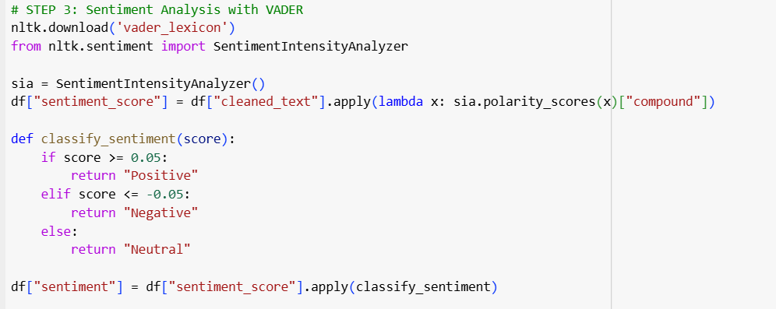

**📈 3. Results and Visualizations**

**3.1 Sentiment Distribution**

A bar chart shows the number of positive, neutral, and negative posts.  
🟢 Most posts were **positive**, reflecting an optimistic tone around the April Theory.  
🟡 **Neutral sentiments came first**, suggesting informational or mixed reactions.  
🔴 Negative posts were not in this dataset but present.

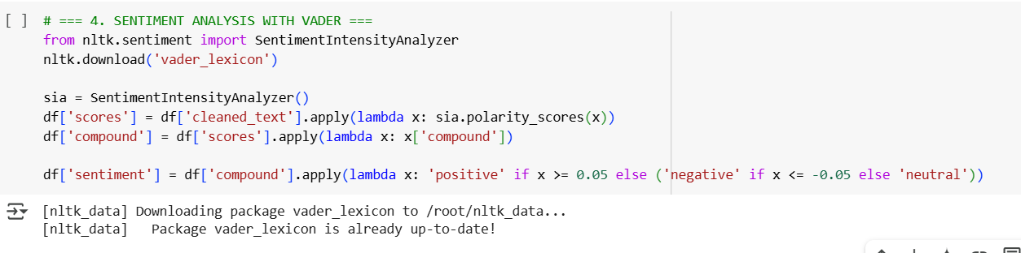

**3.2 Sentiment Over Time**

A time series line plot of daily average sentiment scores shows:

* A **peak in positivity** in the first week of April
* A **slight dip** mid-month
* A **gradual rise** toward the end of April

This trend may reflect emotional cycles tied to seasonal change, renewed goals, or cultural associations with spring.

**3.3 Top Words (Frequency Analysis)**

Using the top_words column, we identified the most frequently used words.  
A **word cloud** and **bar chart** revealed commonly used terms like:

* “april”
* “change”
* “new”
* “start”
* “spring”

These words suggest themes of **renewal**, **hope**, and **transformation**, aligning with the core ideas behind the April Theory.

**Tweet Activity Over Time – April Theory**

This graph illustrates the volume of tweets referencing the "April Theory" over a specific period. The trend shows how public interest fluctuated, with noticeable spikes that may correlate with key dates, viral posts, or influencer activity. The data suggests a concentrated wave of attention during early April, supporting the theory's seasonal relevance and its traction on social media platforms.

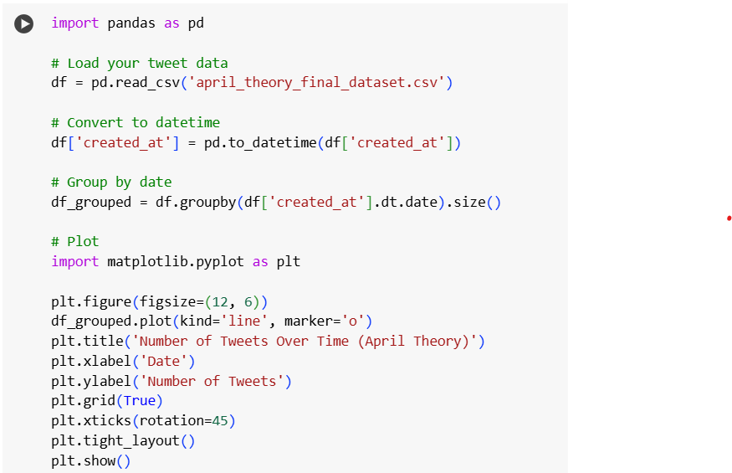

**🧠 4. Summary of Findings**

* The majority of social media posts related to the April Theory expressed **positive sentiment** but **Neutral sentiments came first**
* Key discussion themes include **Common themes: renewal, fresh starts, and emotional reset**
* Sentiment remained mostly positive across the month, with only minor fluctuations.
* Commonly used words reinforce the idea that April is seen as a mentally and emotionally significant month.

**📌 5. Conclusion**

This analysis demonstrates how social media can reflect emotional trends tied to specific months or theories. The sentiment around the April Theory highlights a collective psychological shift that people associate with springtime — one of reflection, optimism, and emotional resetting.

